

Game Room Server

# **CS 230 Project Software Design Template**

Version 1.0

## Table of Contents

**CS 230 Project Software Design Template**1

**Table of Contents**2

**Document Revision History**2

**Executive Summary**3

**Design Constraints**3

**System Architecture View**3

**Domain Model**3

**Evaluation**3

**Recommendations**5

## Document Revision History

| Version | Date | Author | Comments |
| --- | --- | --- | --- |
| 1.0 | 05/23/2021 | Diego Vasquez | Initial implementation of classes. |

**Instructions**

Fill in all bracketed information on page one (the cover page), in the Document Revision History table, and below each header. Under each header, remove the bracketed prompt and write your own paragraph response covering the indicated information.

## Executive Summary

The staff would like to implement a web-based version of their android application (The Gaming Room), but do not know how. The solution is to prepare a software design document and implement the application based on their requirements.

## Design Constraints

<Identify the design constraints for developing the game application in a web-based distributed environment and explain the implications of the design constraints on application development.>

The design constraints for developing any game application in a web-based environment are the limitations of a web browser. This means that the application is itself run on Java Applets, but given that applets are an antiquated technology, what most likely will happen is that certain components are served by a Java server while the game codebase itself is written in JavaScript. These are the design constraints: The browser limitations, and the capabilities of JavaScript and Java.

## System Architecture View

Please note: There is nothing required here for these projects, but this section serves as a reminder that describing the system and subsystem architecture present in the application, including physical components or tiers, may be required for other projects. A logical topology of the communication and storage aspects is also necessary to understand the overall architecture and should be provided.

## Domain Model

The ProgramDriver class uses the SingleTonTester class to test an instance of ProgramDriver. The Entity class has two variables, a constructor method, getters and setters and several other methods that are inherited to the Game, Team, and Player classes. The Game service has a 0 to many relationship to the Game class, while the Game class has a 0 to many relationship to the Team class and the Team class has a 0 to many relationship to the PlayerClass.

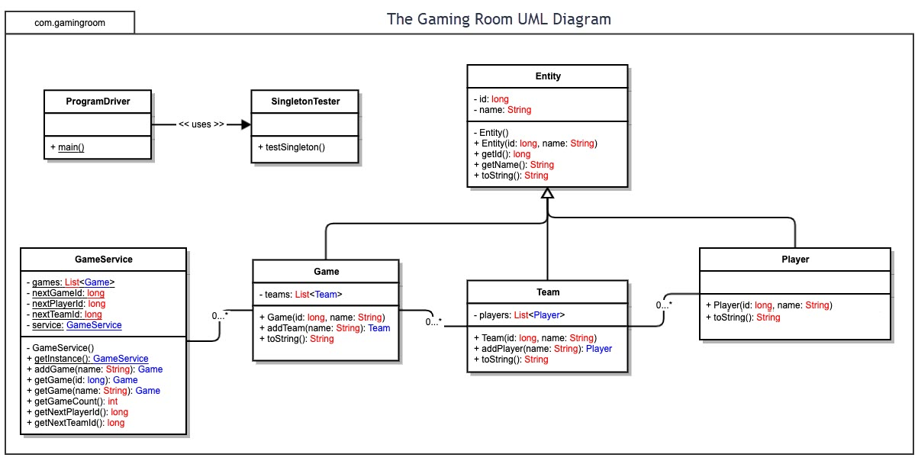

## Evaluation

Using your experience to evaluate the characteristics, advantages, and weaknesses of each operating platform (Linux, Mac, and Windows) as well as mobile devices, consider the requirements outlined below and articulate your findings for each. As you complete the table, keep in mind your client’s requirements and look at the situation holistically, as it all must work together.

In each cell, remove the bracketed prompt and write your own paragraph response covering the indicated information.

| **Development Requirements** | **Mac** | **Linux** | **Windows** | **Mobile Devices** |
| --- | --- | --- | --- | --- |
| **Server Side** | MacOS should have no issues hosting server-side code. Since MacOS is a popular operating system, most developers should be comfortable using it. | Linux can allow greater control and depending on the distribution of Linux, the server hosting process can be very easy or very difficult. | Windows is a very popular option if the goal is to quickly setup a server. | There is no reason to host a server on a mobile device as that device would have to be on constantly. |
| **Client Side** | Mac is a good option for client-side code. Because many developers use Mac, there should not be issues using Bash for developers, or writing applications compatible with MacOS. | While Linux is gaining popularity, not everyone knows Linux, and potential new issues can arise in the operating system that might hinder the development process. | As mentioned before, Windows is very popular and thus most users and developers are comfortable using this operating system. Hence most software is written with the idea that it will run on Windows. | There needs to be developers who understand mobile app development so that will be an extra cost, but because most people own mobile devices, the application will gain a stronger presence. |
| **Development Tools** | Java can be used on MacOS, and HTML, CSS, and JavaScript can also be used, for scripts, developers use the shell, and for version control, they use Git and GitHub. | Just like on a MacOS computer, the same languages can be used for development, and the terminal is used for scripts. | For scripts, the command line is used, but one can choose to use PowerShell. Again, Java, HTML, CSS, and JavaScript can all be used on Windows. | There is software to develop android apps such as android studio, but this is used on a computer, not on the actual mobile device. For developing on an actual mobile device, software like AIDE could help, but it is simply faster to develop it on a computer then test it on an emulation of Android or MacOS. |

## Recommendations

Analyze the characteristics of and techniques specific to various systems architectures and make a recommendation to The Gaming Room. Specifically, address the following:

1. **Operating Platform**: <Recommend an appropriate operating platform that will allow The Gaming Room to expand Draw It or Lose It to other computing environments.>

**Because Java runs in a virtual machine, applications created with Java are already OS agnostic, therefore, expansion to another operating platform can be made more smoothly. One of these platforms could be mobile devices, where the codebase is modified per the limitations of mobile devices.**

1. **Operating Systems Architectures**: <Describe the details of the chosen operating platform architectures.>

**A mobile device, whether it is iOS or Android can run Java applications, while it is popular to create two separate native applications (one for iOS and one for Android), it is cost effective to have a single codebase for both operating systems. Java has been optimized over the years to perform faster than before despite running through the JVM.**

1. **Storage Management**: <Identify an appropriate storage management system to be used with the recommended operating platform.>

**In my opinion, using a relational database such as MySQL or PostgreSQL could be two very good options, with MySQL being my first recommendation given that it is now an Oracle product and is highly compatible with Java. Using MySQL can allow a database administrator to create a robust database with the necessary relationships between tables that will respond to a Java server (Spring boot perhaps?) with accurate data.**

1. **Memory Management**: <Explain how the recommended operating platform uses memory management techniques for the Draw It or Lose It software.>

**One important feature in the Java programming language is asynchronous code and concurrency, the ability to continue performing other actions while a task without a time estimate is being completed while running other tasks, and the ability to multiple tasks at the same time. I think using these features can help prevent bottlenecks and provides a better user experience because a user might see a loading screen while a task is being done or may be able to do other things while waiting for a task to be completed instead of the application freezing every time they perform a memory intensive task.**

1. **Distributed Systems and Networks**: <Knowing that the client would like Draw It or Lose It to communicate between various platforms, explain how this may be accomplished with distributed software and the network that connects the devices. Consider the dependencies between the components within the distributed systems and networks (connectivity, outages, and so on).>

**I would recommend hosting the MySQL server on the cloud as it would account for any possible connectivity issues since cloud servers are hosted in different locations and that means people from different countries should have less issues connecting to the app. There is the added cost of setting up and paying for the cloud (which has become much easier), but it would ensure a good connection across the globe for users.**

1. **Security**: <Security is a must-have for the client. Explain how to protect user information on and between various platforms. Consider the user protection and security capabilities of the recommended operating platform.>

**Again, Java being OS agnostic, one can implement the appropriate security features Java provides, one of them being user authentication. Apart from the server, the database should be made secure so that users are not able to obtain sensitive information.**